Guynes Daniel M (Contractor)

daniel.m.guynes@irs.gov

Abstract

This document provides the defined governance template required for all solutions in the IRS Power Platform tenant that serve a production quality service.

power platform Solution Design Template

IRS Power Platform Solution Governance

# Table of Contents

Table of Contents 1

Table of Tables 2

Table of Figures 2

Document Revision History 3

Purpose 4

Information 4

Instructions 0

Step 1: Solution Objects 0

Step 2: Connection References 0

Step 3: Data Storage Mapping 0

Step 4: Data Storage Details 1

Step 5: Custom Security Roles 1

Step 6: Production Environment Security Teams (Entra Security Groups) 2

Step 7: Use Case Diagrams 2

Step 8: Comments, Notes or Instructions 3

Appendix A: Sample Solution Object List 4

Appendix B: Sample Connection References 5

Appendix C: Sample Data Storage Mapping 6

Appendix D: Sample Data Storage Details 7

Appendix E: Sample Custom Security Roles 9

Appendix F: Sample Production Environment Security Groups 10

Appendix G: Sample Use Case Diagrams 0

Visual Diagrams 0

Textual Diagrams 0

# Table of Tables

Table 1: Document Revision History 3

Table 2: Solution Objects 0

Table 3: Connection References 0

Table 4: Data Storage Mapping 1

Table 5: Data Storage Details 1

Table 6: Custom Security Roles 2

Table 7: Production Environment Security Teams (Entra Security Groups) 2

Table 8: Sample Solution Object List 4

Table 9: Sample Connection References 5

Table 10: Sample Data Storage Mapping 6

Table 11: Sample Data Storage Details 1 7

Table 12: Sample Data Storage Details 2 7

Table 13: Sample Data Storage Details 3 7

Table 14: Sample Data Storage Details 4 8

# Table of Figures

Figure 1: Sample Work Code Application User Use Case 0

# Document Revision History

|  |  |  |
| --- | --- | --- |
| Editor | Date Edited | Comments |
| Daniel Guynes (contractor) | 2.10.2025 | Initial document creation |
|  |  |  |
|  |  |  |

Table 1: Document Revision History

# Purpose

The purpose of this document is to define the core elements of the Power Point Solution to ensure best practice DevSecOps (Development – Security – Operations). This document is required to be completed and approved by the Power Platform governing body prior to any Power Platform Solution being deployed into a production state.

A Power Point Solution is defined as any Power Platform object (app, form, flow, BI dashboard, or other object created within a Power App, Power Automate or Power BI environment) used by more than one person for work productivity.

# Information

The Instructions section will walk you through the process of filling out this document and having it approved in a quick and timely manner.

Please note that this document is ***required*** before your solution may be initially deployed or used in a Production manner and should be submitted to the Power Platform Governance Board (XXX.XXX@irs.gov) no more than 10 days prior to your intended solution deployment date.

** NOTICE **  
*This only needs to be done* ***once*** *for your initial deployment to production. After the initial deployment into production, you may deploy without the need for submitting new documentation.*

*However, if your Power Platform Solution goes through a defined number of changes that reflect a likely architectural change the Power Platform Governance Board will request to update your documentation. This will serve the purpose of ensuring governance remains high, and your system is well documented.*

# Instructions

These instructions will walk you through the process of filling out this document and having it approved in a quick and timely manner.

* Fill this document out completely and accurately.
* Fill out all fields in this document marked Required or with a red asterisk *.
* If you do NOT have data for a specific Step, in the first line across all columns enter ***Not Applicable*** or ***NA***.

## Step 1: Solution Objects

*Required*

List ***ALL*** objects in your Solution and provide a description of the purpose of the object.  
**NOTE: See** **Appendix A** **for an example**

|  |  |  |
| --- | --- | --- |
| Object Name | Object Type | Descriptive purpose |
|  |  |  |
|  |  |  |
|  |  |  |
|  |  |  |
|  |  |  |
|  |  |  |

Table 2: Solution Objects

## Step 2: Connection References

*Required*

List ***all*** connection references in your Power Platform Solution and note if they require Premium license (i.e. SQL, Oracle, Dataverse, etc.).  
**NOTE: See** **Appendix B** **for an example**

|  |  |  |  |
| --- | --- | --- | --- |
| Connection Reference Name | Premium? | Security Change Management Approval ID | Descriptive purpose |
|  |  |  |  |
|  |  |  |  |

Table 3: Connection References

## Step 3: Data Storage Mapping

*Required*

This should be a list of your objects and their connection to your underlying data storage.

If you do NOT have Data Storage, in the first line across all columns enter ***Not Applicable*** or ***NA***.

**NOTE: See** **Appendix C** **for an example**

|  |  |  |  |  |
| --- | --- | --- | --- | --- |
| Power Platform Object | Connection Reference | Data Action(s) | PII or FTI Data? | Data Storage |
|  |  |  |  |  |
|  |  |  |  |  |
|  |  |  |  |  |
|  |  |  |  |  |
|  |  |  |  |  |

Table 4: Data Storage Mapping

## Step 4: Data Storage Details

*Required*

For each data storage (SharePoint list, Dataverse table, SQL or Oracle table, Excel Spreadsheet, etc.) that is used, fill in a table for each data storage that data is read from, or inserted, updated, or deleted from.

Each table should be listed in a separate table (simply copy the table below and Table header for each data store)

If you do NOT have Data Storage details, in the first line across all columns enter ***Not Applicable*** or ***NA***.

**NOTE: See** **Appendix D** **for an example**

[Table Name] – [Table Type]

|  |  |  |
| --- | --- | --- |
| Field / Column Name | Date Type | Purpose of data |
|  |  |  |
|  |  |  |
|  |  |  |
|  |  |  |
|  |  |  |

Table 5: Data Storage Details

## Step 5: Custom Security Roles

*Required*

For each custom Security Role, define the security role and determine if this Security Role is accessing

If you do NOT have Custom Security Roles, in the first line across all columns enter ***Not Applicable*** or ***NA***.

**NOTE: See** **Appendix E** **for an example**

|  |  |  |
| --- | --- | --- |
| Security Role Name | Access to PII or FTI Data | Descriptive purpose of Security Role |
|  |  |  |
|  |  |  |
|  |  |  |
|  |  |  |
|  |  |  |

Table 6: Custom Security Roles

## Step 6: Production Environment Security Teams (Entra Security Groups)

*Required*

Enter all Entra Security Groups that are non-system or Power Platform Admin related that pertain to the use of the Solution objects.

**NOTE: See** **Appendix F** **for an example**

|  |  |  |  |
| --- | --- | --- | --- |
| Security Group Name | Projected # of Users | Custom Security Role(s) | Descriptive purpose of Group |
|  |  |  |  |
|  |  |  |  |
|  |  |  |  |
|  |  |  |  |
|  |  |  |  |

Table 7: Production Environment Security Teams (Entra Security Groups)

## Step 7: Use Case Diagrams

*Required*

You may provide a graphic or a textual Use Case. Use Cases are important in defining the ultimate goal of your Solutions and applications and serve as a guide for your business in understanding core business functions. A Use Case should be simple, but provide the actual work or process done to accomplish a goal or business function.

**NOTE: See** **Appendix G** **for an example**

## Step 8: Comments, Notes or Instructions

(optional)

This section allows the group submitting the Solution Design document the ability to provide any additional notes, comments, or instructions related to this document or the deployment of the solution into production.

# Appendix A: Sample Solution Object List

List everything that is part of your Solution. Simply open you Solution and list all items that are part of your Solution.

Below is a sample list of a Solution that provides an application called Work Hours, where users go to record their hours against Work Codes each day.

Back to Step 1: Solution Objects

|  |  |  |
| --- | --- | --- |
| Object Name | Object Type | Descriptive purpose |
| Work Hours App | Power App | Users enter their daily time against specific work codes to track hours worked against defined items. |
| Work Hours Flow | Cloud flow | This flow kicks off when a user enters a row of data into the Work Hours App. It sends a confirmation email to the user who entered the data, as well as their reporting manager. |
| Work Hours Session Update | Cloud Flow | This flows pulls from a SQL Server to load the latest work codes into our Dataverse tables to be used and consumed by the Work Hours App |
| SQL Connection-37ud6 | Connection reference | Connection to SQL Server – used by the Work Hours Session Update flow |
| Office 365 Outlook Work Hours-8293us | Connection reference | Connection to Outlook User Groups – used in Work Hours Flow and Work Hours Session Update flow to send emails to pertinent personnel. |
| Dataverse-237ew | Connection reference | Connection to Dataverse to store data in production |
| Work Hours Tbl | Dataverse | Table to store the core data behind the Work Hours App |
| Work Hours Codes Tbl | Dataverse | Table to store all the Work hours codes from SQL. |
| EnvVarSQL | Environment Variable | This variable is used in the SQL connection to change between Dev, Test, and Prod SQL environments within the Work Hours Flow. |
| WorHoursManagers | Security Role | Manager Role … allows managers to see reports in Work Hours App on users hours against Work Codes, and allows them to edit if needed after the hours have been entered. |
| WorkHoursUsers | Security Role | User Role … allows users to enter data via the Work Hours app – they can only insert or edit current work hour data, or review (read) past data. |
| StaticDataPull | Data Flow | Pulls support data from Sandbox for static values set for drop downs and combo boxes that are relevant but rarely change. |

Table 8: Sample Solution Object List

Back to Step 1: Solution Objects

# Appendix B: Sample Connection References

This is a list just of the Connection References. The primary difference between the data you enter here and in the Solution table is whether the connections are Premium, and if they are you need to provide the Security Change Management Approval ID.

Back to Step 2: Connection References

|  |  |  |  |
| --- | --- | --- | --- |
| Connection Reference Name | Premium? | Security Change Management Approval ID | Descriptive purpose |
| SQL Connection-37ud6 | Yes | SecChMng12182024-235 | Connection to SQL Server – used by the Work Hours Session Update flow |
| Office 365 Outlook Work Hours-8293us | No | NA | Connection to Outlook User Groups – used in Work Hours Flow and Work Hours Session Update flow to send emails to pertinent personnel. |
| Dataverse-237ew | Yes | NA | Connection to Dataverse to store data in production |

Table 9: Sample Connection References

Back to Step 2: Connection References

# Appendix C: Sample Data Storage Mapping

This is a simple list of data interaction. This table should record the data flow from Source to Target and the actions that are allowed. For example, in Row one below you note that the Data interaction originates from the Work Hours App, where the user has the ability to Create, Read, Update, or Delete data on the Target data source https://it-aaa-bbb-prod.crm9.dynamics.com/Dataverse.

Back to Step 3: Data Storage Mapping

|  |  |  |
| --- | --- | --- |
| Source | Data Action(s) | Target |
| Work Hours App | Create, Read, Update, Delete | https://it-aaa-bbb-prod.crm9.dynamics.com/Dataverse.Work Hours  https://it-aaa-bbb-prod.crm9.dynamics.com/Dataverse.Work Hour Users  Excel Spreadsheet.Work Hour Drop Down.Columns[A2-A10] |
| Work Hours Flow | Create, Read, Update, Delete | https://it-aaa-bbb-prod.crm9.dynamics.com/Dataverse. |
| Work Hours Session Update | Read | \\VSTQSYEKSU\MyData (SQL Server instance).Work Hour Issues |
|  |  |  |
|  |  |  |

Table 10: Sample Data Storage Mapping

Back to Step 3: Data Storage Mapping

# Appendix D: Sample Data Storage Details

In these tables, you want to define the details of the tables of the data you are storing data or pulling data from. While you do not divulge the data, it allows the Power Platform Governance Board insight into the type of data being used, as well as serves your organization well in providing depth into your code structure and data requirements for future development.

Back to Step 4: Data Storage Details

**Work Hours – Dataverse Table**

|  |  |  |
| --- | --- | --- |
| Field / Column Name | Date Type | Purpose of data |
| Id | Unique Id | Provided by default by System |
| Work Code | Single Line of Text | The Work Code value from the SQL table |
| HoursBilled | Number (1 decimal place) | The hours the user billed against the Work Code |
| DateBilled | Datetime | The date they billed their hours for |
| User | Person | The User entering the data |
| IsApproved | Yes/No | Yes/No whether the billing has been approved |
| Approver | Person | The Approving Manager |
| ApprovalDate | Datetime | The date they approved the billing |

Table 11: Sample Data Storage Details 1

**Work Hour Users – Dataverse Table**

|  |  |  |
| --- | --- | --- |
| Field / Column Name | Date Type | Purpose of data |
| Id | Unique Id | Provided by default by System |
| User | Person | The user entering hours |
| User Type | Choice | The type of user [Manager, Service Provider, Analyst, etc.] |
| IsActive | Yes/No | Boolean if the user is active or not active |

Table 12: Sample Data Storage Details 2

**Work Hour Issues – SQL table**

|  |  |  |
| --- | --- | --- |
| Field / Column Name | Date Type | Purpose of data |
| Id | Long | Unique Identifier |
| Work Code | Varchar(50) | Work Code value |
| Work Code Description | Varchar(500) | Work Code description |
| Active | Bit | Flag 0/1 if Work item is active or not |
| Work Code Start Date | Datetime | Date the Work Code may be billed against |
| Work Code End Date | Datetime | Date t he Work Code is no longer capable of being billed against |

Table 13: Sample Data Storage Details 3

**Work Hour Drop Down – Excel file**

|  |  |  |
| --- | --- | --- |
| Field / Column Name | Date Type | Purpose of data |
| Column A [A2 – A10] | Number | This is a list of Years from 7 years back to next year. |

Table 14: Sample Data Storage Details 4

Back to Step 4: Data Storage Details

# Appendix E: Sample Custom Security Roles

Enter any custom security roles created to support Dataverse or other purposes.

Back to Step 5: Custom Security Roles

|  |  |  |
| --- | --- | --- |
| Security Role Name | Access to PII or FTI Data | Descriptive purpose of Security Role |
| Work Code User | No | Provides minimal access and only specific to them – to enter data into the Work Code table in the Dataverse. |
| Work Code Manager | PII | Provides Managers the ability to view multiple employees and see their Work Code billing against work codes. |

Back to Step 5: Custom Security Roles

# Appendix F: Sample Production Environment Security Groups

Enter all Entra Security Groups that are non-system or Power Platform Admin related that pertain to the use of the Solution objects.

Back to Step 6: Production Environment Teams (Entra Security Groups)

|  |  |  |  |
| --- | --- | --- | --- |
| Security Group Name | Projected # of Users | Custom Security Role(s) | Descriptive purpose of Group |
| CLOUD M365 MPP IT BU WC Users | 250 | Work Code User | This Security group contains all the users who enter their hours against the various Work Codes available. |
| CLOUD M365 MPP IT BU WC Managers | 25 | Work Code Manager | This Security group contains all the managers who approve Work Code billings for their specific group of users. |

Back to Step 6: Production Environment Teams (Entra Security Groups)

# 

# Appendix G: Sample Use Case Diagrams

You may provide a graphic or a textual Use Case. Use Cases are important in defining the ultimate goal of your Solutions and applications. A Use Case should be simple, but provide the actual work or process done to accomplish a goal or business function.

This section provides two samples: a Visual Diagram using PowerPoint; a textual representation of a Use Case.

Back to Step 7: Use Case Diagrams

## Visual Diagrams

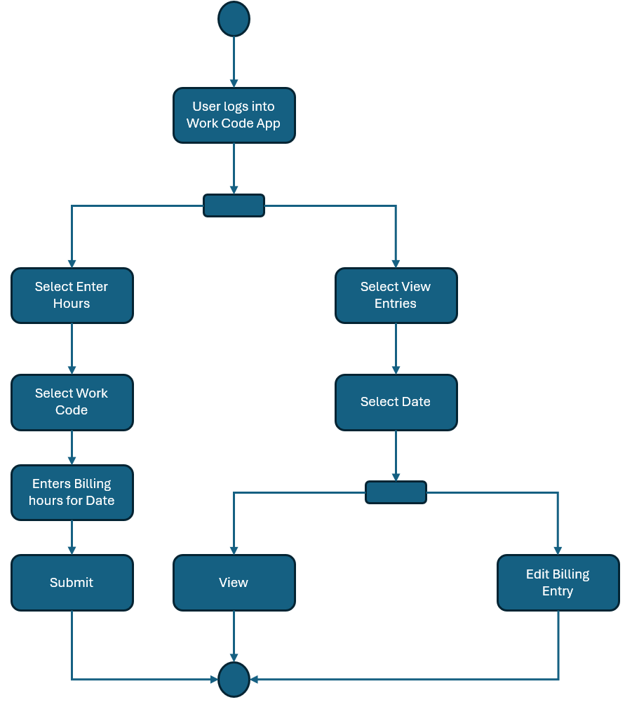

Figure 1: Sample Work Code Application User Use Case

## Textual Diagrams

1. Manager enters the Work Code Application
2. Manager is presented with the Home page
3. Manager chooses Work Codes (skip to 5)
4. Manager chooses Review Entries
   1. Manager clicks Approve button next to a billing entry
   2. Manager clicks Deny button next to a billing entry
      1. Manager is prompted with a Reason for Denial text box
      2. Click Submit
   3. Manager clicks Edit button next to a billing entry
      1. Manager updates the billing information
      2. Click Submit
5. Manager is presented with a new page with list of Work Codes
   1. Manager clicks Edit next to a work code entry
      1. Manager is prompted with a pop-up to edit the Work Code
         1. Manager edits the Work Code fields
         2. Manager clicks submit
         3. Back to 5
6. Manager clicks Home navigation button
   1. Back to 2

Back to Step 7: Use Case Diagrams